ANKARA UNIVERSITY
FACULTY OF ENGINEERING – DEPARTMENT OF COMPUTER ENGINEERING

COM2058 – DATABASE MANAGEMENT SYSTEMS
Final Project Report
Work and Travel (WAT) Student Management System


Faik Yılmaz 23291024
Furkan Duran 22290579
Ahmet Can 23291550
Supervisor: Department of Computer Engineering
Submission Date: May 29, 2026

Table of Contents
1. Introduction 3
1.1 Project Overview 3
1.2 Scope 3
1.3 Project Team 4
2. System Requirements 5
2.1 Functional Requirements 5
2.2 Non-Functional Requirements 5
2.3 Business Rules and Assumptions 6
3. Database Design 7
3.1 Conceptual Model 7
3.2 Relationships and Cardinalities 7
3.3 Logical Schema (Tables) 8
3.4 Foreign Keys and Referential Integrity 10
3.5 Normalization 11
4. Implementation 12
4.1 Technology Stack 12
4.2 Schema Creation (DDL) 12
4.3 Sample Data Population (DML) 14
4.4 Application Architecture 14
4.5 Database Connectivity 15
4.6 Authentication 15
4.7 Concurrent Job Application 16
4.8 User Interface 16
5. Representative SQL Queries 18
5.1 Q1 — Students Whose Visa Is Pending 18
5.2 Q2 — Total Payments Collected per Agency 18
5.3 Q3 — Highest-Paying Position per State 19
5.4 Q4 — Personal Process Dashboard 20
5.5 Q5 — Jobs With No Active Application 20
6. Conclusion 22

1. Introduction

1.1 Project Overview
The Work and Travel (WAT) program is a cultural exchange initiative that allows university students to legally work and travel in the United States during their summer holidays under a J-1 non-immigrant visa. The program brings together four core participant groups: university students who apply to participate, consultancy agencies who guide the students through the bureaucratic process, U.S.-based employers who hire the students for seasonal positions, and housing providers who accommodate them near their workplaces. Managing the interactions between these groups manually, with spreadsheets and e-mails, is error-prone and quickly becomes unmanageable as the number of applicants grows.
This project addresses that problem by designing and implementing a centralized Work and Travel Student Management System backed by a relational database. The system is built on Microsoft SQL Server (SQL Server Express 2022) and is accessed through a desktop Java client written in Java Swing using JDBC for connectivity. The database schema is normalized up to the third normal form (3NF) and uses primary keys, foreign keys, and CHECK-style application logic to preserve referential integrity across all nine tables.
The end goal is a working academic prototype that demonstrates the full life-cycle of a Work and Travel applicant — from agency registration, through payment and visa processing, to job application and housing assignment — all anchored on a clean relational schema.

1.2 Scope
Within the scope of this project the system supports the following functional capabilities:
- Registering students under exactly one consultancy agency per season and storing their academic major for filtering purposes.
- Tracking financial transactions (program fees, installment payments) for each student through dated payment records.
- Recording the status of the visa application process, including SEVIS identifier, consulate interview date, and current status (Approved, Pending, Action Required).
- Allowing U.S.-based employers to post job offers with position title, hourly wage and location.
- Letting students browse employers and positions and apply through an APPLICATION bridge entity that resolves the many-to-many relationship between students and job offers.
- Storing housing options linked to the same geographical location as the job offers so that an accepted student can choose accommodation close to the workplace.
- Enforcing concurrency rules at the application layer — for example, a Server-Side check that prevents two students from being accepted to the same job position.

1.3 Project Team
The project was developed collaboratively by three students from Ankara University, Department of Computer Engineering:
Name | Student ID | Primary Responsibility
Faik Yılmaz | 23291024 | Database schema design, SQL data definition & population
Furkan Duran | 22290579 | Java back-end (JDBC layer, business logic) and SQL queries
Ahmet Can | 23291550 | Java Swing user interface, integration and testing

Although each member led a primary area, the work was reviewed jointly and the entire team contributed to the final schema, the reporting queries, and the documentation submitted with this report.

2. System Requirements

2.1 Functional Requirements
The system must satisfy the following functional requirements, which are derived from the operational workflow of a real Work and Travel agency:
- FR-1 — The system shall allow each student to authenticate using their official university e-mail address and a personal password before viewing or interacting with any data.
- FR-2 — The system shall ensure that every student belongs to exactly one agency for the current season.
- FR-3 — The system shall record every payment made by a student with the amount, date, and student identifier and the amount must be strictly greater than zero.
- FR-4 — The system shall maintain a one-to-one relationship between a student and their visa process record, including the SEVIS ID, interview date and current status.
- FR-5 — The system shall let employers post multiple job offers, each tied to a specific location, position title, and hourly wage.
- FR-6 — The system shall present students with the list of employers and their open positions and let them submit a single primary application that becomes the basis of their job placement.
- FR-7 — The system shall prevent a job from being filled twice — once an application reaches the 'Accepted' state, no further applications for that JobID may be inserted.
- FR-8 — The system shall display, on a single dashboard, the visa status, accepted job and assigned housing of a logged-in student.

2.2 Non-Functional Requirements
- Reliability — The desktop client must gracefully handle a database outage by showing a 'Server Unavailable' notification rather than crashing.
- Security — All credentials are validated against the database through prepared statements (PreparedStatement) to prevent SQL injection.
- Maintainability — The Java code is split into three layers: db (persistence), model (POJOs) and ui (Swing views), so that schema or interface changes can be localised.
- Portability — The schema is written in standard T-SQL (SQL Server dialect) and the Java client uses the official Microsoft JDBC driver, which means deployment is independent of the operating system that hosts the client.

2.3 Business Rules and Assumptions
- Each student is assigned to exactly one agency per Work and Travel season.
- A student must be registered in the STUDENT table before any payment or application record may reference them — referential integrity is enforced at the FOREIGN KEY level.
- Payment amounts are stored in DECIMAL(8,2) and are always positive.
- Housing cost per week is stored in DECIMAL(6,2) and must be positive.
- Historical records (payments, applications) are retained indefinitely for audit purposes — a soft-delete philosophy is adopted; physical DELETE statements are avoided in the operational layer.
- A student may submit only one Primary application; subsequent applications are blocked at the application layer once an 'Accepted' record exists.

3. Database Design

3.1 Conceptual Model
The conceptual model is captured as a Chen-style Entity-Relationship diagram. Nine entities form the backbone of the system and are linked through seven named relationships.
Six entities — STUDENT, AGENCY, EMPLOYER, JOB_OFFER, LOCATION and HOUSING — represent the principal real-world concepts. Two — VISA_PROCESS and PAYMENT — represent dependent records that exist only with respect to a student. The ninth, APPLICATION, is a junction entity that resolves the many-to-many relationship between students and job offers.
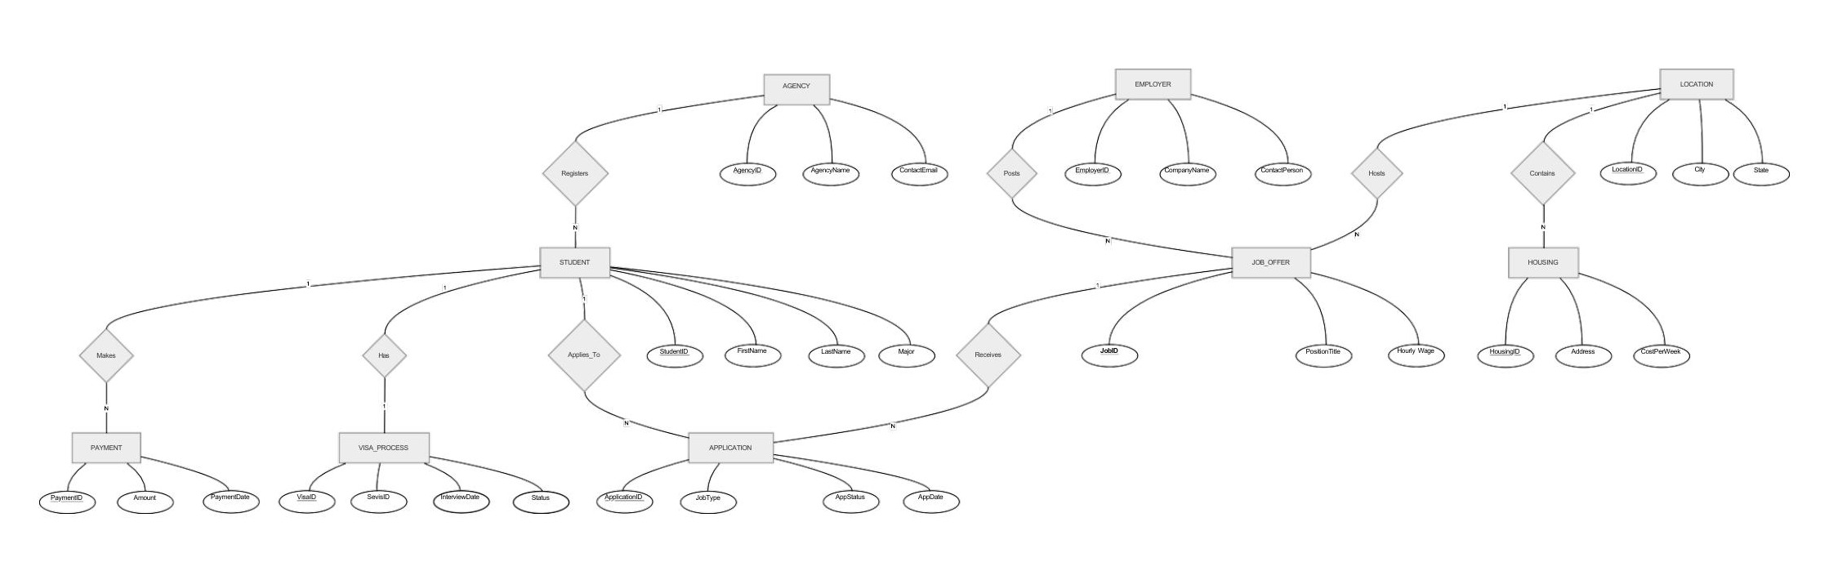
Figure 1. Entity-Relationship diagram of the WAT Student Management System.

3.2 Relationships and Cardinalities
The relationships and their cardinality constraints are summarized in the table below. The notation 1:N is read as 'one to many', so for example a single agency may register many students, but each student is registered with only one agency.

Relationship | Entities | Cardinality | Description
Registers | AGENCY — STUDENT | 1 : N | An agency registers many students; each student belongs to one agency.
Makes | STUDENT — PAYMENT | 1 : N | A student may pay in multiple installments.
Has | STUDENT — VISA_PROCESS | 1 : 1 | Each student has exactly one visa record per season.
Applies_To | STUDENT — APPLICATION | 1 : N | A student may submit several applications (one Primary).
Receives | JOB_OFFER — APPLICATION | 1 : N | A job offer may receive applications from several students.
Posts | EMPLOYER — JOB_OFFER | 1 : N | An employer publishes many distinct positions.
Hosts | LOCATION — JOB_OFFER | 1 : N | A location may host many job offers.
Contains | LOCATION — HOUSING | 1 : N | A location contains several housing options.

3.3 Logical Schema (Tables)
The conceptual design was translated into nine relational tables. The following sub-sections describe each table together with its attributes, data types, and key constraints. Primary keys are underlined in the heading and foreign keys are explicitly tagged as (FK).

3.3.1 AGENCY
Attribute | Type | Constraint | Description
AgencyID | INT | PRIMARY KEY | Unique identifier of the agency.
AgencyName | VARCHAR(100) | NOT NULL (logical) | Official name of the agency.
ContactEmail | VARCHAR(100) | Logically UNIQUE | Official communication e-mail.

3.3.2 LOCATION
Attribute | Type | Constraint | Description
LocationID | INT | PRIMARY KEY | Unique identifier of the location.
City | VARCHAR(100) | — | City name (e.g. Ocean City, Nashville).
State | VARCHAR(5) | — | Two-letter U.S. state code (e.g. MD, TN).

3.3.3 EMPLOYER
Attribute | Type | Constraint | Description
EmployerID | INT | PRIMARY KEY | Unique identifier of the employer.
CompanyName | VARCHAR(150) | — | Legal company name.
ContactPerson | VARCHAR(100) | — | HR or operations contact at the company.

3.3.4 STUDENT
Attribute | Type | Constraint | Description
StudentID | INT | PRIMARY KEY | University student number.
FirstName | VARCHAR(50) | — | Given name.
LastName | VARCHAR(50) | — | Family name.
Major | VARCHAR(100) | — | Academic department.
AgencyID | INT | FK → AGENCY(AgencyID) | Registered agency.
email | VARCHAR(100) | Used for authentication | Official university e-mail.
password | VARCHAR(50) | Used for authentication | Personal login password.
Note: The email and password attributes were added during the user-interface stage of the project so that the Java Swing client could authenticate students through a real sign-in form.

3.3.5 JOB_OFFER
Attribute | Type | Constraint | Description
JobID | INT | PRIMARY KEY | Unique identifier of the offer.
PositionTitle | VARCHAR(100) | — | Job title (Server, Lifeguard, …).
HourlyWage | DECIMAL(5,2) | — | Hourly pay in U.S. dollars.
EmployerID | INT | FK → EMPLOYER(EmployerID) | Hiring company.
LocationID | INT | FK → LOCATION(LocationID) | Geographic location.

3.3.6 HOUSING
Attribute | Type | Constraint | Description
HousingID | INT | PRIMARY KEY | Unique housing identifier.
Address | VARCHAR(200) | — | Postal address.
CostPerWeek | DECIMAL(6,2) | Logically > 0 | Weekly rental fee.
LocationID | INT | FK → LOCATION(LocationID) | Location of the unit.

3.3.7 VISA_PROCESS
Attribute | Type | Constraint | Description
VisaID | INT | PRIMARY KEY | Visa record identifier.
SevisID | VARCHAR(20) | — | SEVIS identifier issued by DS.
InterviewDate | DATE | NULL allowed | Scheduled consulate interview.
Status | VARCHAR(50) | — | Approved / Pending / Action Required.
StudentID | INT | FK → STUDENT(StudentID) | Owner of the visa record.

3.3.8 PAYMENT
Attribute | Type | Constraint | Description
PaymentID | INT | PRIMARY KEY | Receipt identifier.
Amount | DECIMAL(8,2) | Logically > 0 | Amount paid in USD.
PaymentDate | DATE | — | Date of payment.
StudentID | INT | FK → STUDENT(StudentID) | Paying student.

3.3.9 APPLICATION (Bridge Table)
Attribute | Type | Constraint | Description
ApplicationID | INT | PRIMARY KEY | Application identifier.
AppDate | DATE | — | Submission date.
AppStatus | VARCHAR(50) | — | Pending / Accepted / Rejected.
JobType | VARCHAR(50) | — | Primary / Backup application type.
StudentID | INT | FK → STUDENT(StudentID) | Applying student.
JobID | INT | FK → JOB_OFFER(JobID) | Targeted job.
APPLICATION is the central bridge entity that resolves the inherently many-to-many relationship between STUDENT and JOB_OFFER. By promoting it to its own table we are able to attach attributes (status, date, type) to each individual student/job pair, which would not have been possible in a direct many-to-many association.

3.4 Foreign Keys and Referential Integrity
Five foreign key relationships are declared explicitly in the DDL. Their purpose is to guarantee that no row may reference a non-existent record in the parent table:
- STUDENT.AgencyID → AGENCY.AgencyID — a student cannot belong to an unregistered agency.
- JOB_OFFER.EmployerID → EMPLOYER.EmployerID — a job offer must be published by an existing employer.
- JOB_OFFER.LocationID → LOCATION.LocationID — a job offer must be located in a recorded U.S. location.
- HOUSING.LocationID → LOCATION.LocationID — a housing unit must belong to a recorded location.
- VISA_PROCESS.StudentID → STUDENT.StudentID — a visa record must reference an actual student.
- PAYMENT.StudentID → STUDENT.StudentID — a payment must be tied to a real student.
- APPLICATION.StudentID → STUDENT.StudentID — an application must originate from a real student.
- APPLICATION.JobID → JOB_OFFER.JobID — an application must target an existing job offer.
Together these constraints prevent orphan records: deleting an agency, an employer, or a location while dependent records exist is automatically rejected by the engine, protecting the database from inconsistent states.

3.5 Normalization
All tables are designed in compliance with the Third Normal Form (3NF). Each table has a single-column primary key; every non-key attribute depends on the whole key and not on any other non-key attribute. For example, the city/state pair lives in its own LOCATION table rather than being duplicated inside JOB_OFFER and HOUSING — this removes update anomalies (a city name only needs to be corrected in one place) and keeps the schema compact.

4. Implementation

4.1 Technology Stack
Layer | Technology
Database engine | Microsoft SQL Server Express 2022
DDL / DML | Transact-SQL (T-SQL)
Client | Java 17, Swing
Database driver | Microsoft JDBC Driver for SQL Server (mssql-jdbc)
Build tool | Apache Maven
IDE | IntelliJ IDEA

4.2 Schema Creation (DDL)
The complete data definition script first drops any previous instance of the database and re-creates it from scratch. The full DDL is reproduced below, with foreign keys declared inline:
CREATE DATABASE WAT_Student_Management_System;
USE WAT_Student_Management_System;

CREATE TABLE AGENCY (
AgencyID INT PRIMARY KEY,
AgencyName VARCHAR(100),
ContactEmail VARCHAR(100)
);

CREATE TABLE LOCATION (
LocationID INT PRIMARY KEY,
City VARCHAR(100),
State VARCHAR(5)
);

CREATE TABLE EMPLOYER (
EmployerID INT PRIMARY KEY,
CompanyName VARCHAR(150),
ContactPerson VARCHAR(100)
);

CREATE TABLE STUDENT (
StudentID INT PRIMARY KEY,
FirstName VARCHAR(50),
LastName VARCHAR(50),
Major VARCHAR(100),
AgencyID INT,
email VARCHAR(100),
password VARCHAR(50),
FOREIGN KEY (AgencyID) REFERENCES AGENCY(AgencyID)
);

CREATE TABLE JOB_OFFER (
JobID INT PRIMARY KEY,
PositionTitle VARCHAR(100),
HourlyWage DECIMAL(5,2),
EmployerID INT,
LocationID INT,
FOREIGN KEY (EmployerID) REFERENCES EMPLOYER(EmployerID),
FOREIGN KEY (LocationID) REFERENCES LOCATION(LocationID)
);

CREATE TABLE HOUSING (
HousingID INT PRIMARY KEY,
Address VARCHAR(200),
CostPerWeek DECIMAL(6,2),
LocationID INT,
FOREIGN KEY (LocationID) REFERENCES LOCATION(LocationID)
);

CREATE TABLE VISA_PROCESS (
VisaID INT PRIMARY KEY,
SevisID VARCHAR(20),
InterviewDate DATE NULL,
Status VARCHAR(50),
StudentID INT,
FOREIGN KEY (StudentID) REFERENCES STUDENT(StudentID)
);

CREATE TABLE PAYMENT (
PaymentID INT PRIMARY KEY,
Amount DECIMAL(8,2),
PaymentDate DATE,
StudentID INT,
FOREIGN KEY (StudentID) REFERENCES STUDENT(StudentID)
);

CREATE TABLE APPLICATION (
ApplicationID INT PRIMARY KEY,
AppDate DATE,
AppStatus VARCHAR(50),
JobType VARCHAR(50),
StudentID INT,
JobID INT,
FOREIGN KEY (StudentID) REFERENCES STUDENT(StudentID),
FOREIGN KEY (JobID) REFERENCES JOB_OFFER(JobID)
);

4.3 Sample Data Population (DML)
To exercise the schema, the database is loaded with realistic Work and Travel data: 10 consultancy agencies, 14 U.S. locations across 12 states, 32 employers, 60 job offers, 15 housing units, 25 students (including the three project authors), 25 visa records, 25 payments, and 26 applications.
A short excerpt of the DML script is shown below; the full script is included in the project repository:
-- AGENCIES
INSERT INTO AGENCY (AgencyID, AgencyName, ContactEmail) VALUES
(1, 'Armada Grandee', 'bilgi@armadagrandee.com'),
(2, 'Success', 'ankara@success.com.tr'),
(3, 'YERO', 'ankara@ye-ro.com'),
(4, 'StudyZONE', 'info@studyzone.com.tr'),
(5, 'CampusEDU', 'bilgi@campusedu.com.tr');

-- STUDENTS (project authors highlighted)
INSERT INTO STUDENT (StudentID, FirstName, LastName, Major,
AgencyID, email, password) VALUES
(22290579, 'Furkan', 'Duran', 'Computer Engineering', 2,
'furkan.duran@ankara.edu.tr', 'Wat2026!'),
(23291024, 'Faik', 'Yilmaz', 'Computer Engineering', 1,
'faik.yilmaz@ankara.edu.tr', 'Wat2026!'),
(23291550, 'Ahmet', 'Can', 'Computer Engineering', 2,
'ahmet.can@ankara.edu.tr', 'Wat2026!');

4.4 Application Architecture
The Java client follows a three-layer design that mirrors the standard separation between persistence, domain and presentation:
- db package — DatabaseConnection.java opens the JDBC channel and exposes an availability probe (isServerAvailable); WAT_Student_Management_System.java centralises all parameterised queries (login, getEmployers, getJobsByEmployer, applyToJob, getStudentDashboardSummary).
- model package — Plain Java objects (Student, Employer, JobOffer) that carry result-set rows back to the UI.
- ui package — MainFrame.java implements the Swing windows: login screen, employer list, job list, success screen and a personal dashboard composed as five CardLayout cards.

4.5 Database Connectivity
Connections are obtained through DriverManager with a short login timeout (3 seconds) so that the UI can quickly fall back to an offline state when the server is down. The connection string targets the local SQLEXPRESS instance and authenticates with SQL Server authentication:
private static final String URL =
"jdbc:sqlserver://localhost\\SQLEXPRESS:1433;" +
"databaseName=WAT_Student_Management_System;" +
"encrypt=true;trustServerCertificate=true;";

public static Connection getConnection() throws SQLException {
Class.forName("com.microsoft.sqlserver.jdbc.SQLServerDriver");
return DriverManager.getConnection(URL, USERNAME, PASSWORD);
}

public static boolean isServerAvailable() {
try {
DriverManager.setLoginTimeout(3);
try (Connection ignored =
DriverManager.getConnection(URL, USERNAME, PASSWORD)) {
return true;
}
} catch (Exception e) { return false; }
}

4.6 Authentication
The login routine resolves the supplied e-mail address case-insensitively, but compares the password exactly. The query uses bound parameters so that hostile input cannot break out of the string literal:
String query =
"SELECT StudentID, FirstName, LastName, Major, email " +
"FROM STUDENT WHERE LOWER(email) = LOWER(?) AND password = ?";

try (Connection conn = DatabaseConnection.getConnection();
PreparedStatement ps = conn.prepareStatement(query)) {
ps.setString(1, email);
ps.setString(2, password);
try (ResultSet rs = ps.executeQuery()) {
if (rs.next()) {
return new Student(rs.getInt("StudentID"),
rs.getString("FirstName"),
rs.getString("LastName"),
rs.getString("Major"),
rs.getString("email"));
}
}
}

4.7 Concurrent Job Application
The most interesting back-end routine is applyToJob. The method opens a JDBC transaction, checks whether any existing application for the same JobID has already reached 'Accepted', and only inserts the new application if the position is still open. The auto-increment ApplicationID is computed inline with ISNULL(MAX(...), 0) + 1 to avoid relying on a sequence:
String checkQuery =
"SELECT COUNT(*) FROM APPLICATION " +
"WHERE JobID = ? AND AppStatus = 'Accepted'";

String insertQuery =
"INSERT INTO APPLICATION " +
"(ApplicationID, AppDate, AppStatus, JobType, StudentID, JobID) " +
"VALUES ((SELECT ISNULL(MAX(ApplicationID), 0) + 1 FROM APPLICATION), " +
"GETDATE(), 'Pending', 'Primary', ?, ?)";

try (Connection conn = DatabaseConnection.getConnection()) {
conn.setAutoCommit(false);

/* check whether the job is already taken */
try (PreparedStatement check = conn.prepareStatement(checkQuery)) {
check.setInt(1, jobID);
try (ResultSet rs = check.executeQuery()) {
if (rs.next() && rs.getInt(1) > 0) {
conn.rollback();
return false;
}
}
}

/* insert the new application */
try (PreparedStatement ins = conn.prepareStatement(insertQuery)) {
ins.setInt(1, studentID);
ins.setInt(2, jobID);
ins.executeUpdate();
}
conn.commit();
return true;
}

4.8 User Interface
The Swing client is a five-card flow: LOGIN → EMPLOYER → JOB → SUCCESS → DASHBOARD. A returning student who already has an application in the database is sent straight to DASHBOARD, while a new student starts at EMPLOYER. The screens use a minimal black-on-white palette accented by a single teal colour to highlight success states.
Three operational states of the system are reproduced on the following figures. The first shows the warning dialog that appears whenever the SQL Server service is unreachable, the second shows the personal dashboard rendered after a successful login and confirmed job placement, and the third shows the equivalent SQL Server Management Studio error that surfaces when the SQLEXPRESS instance is offline.
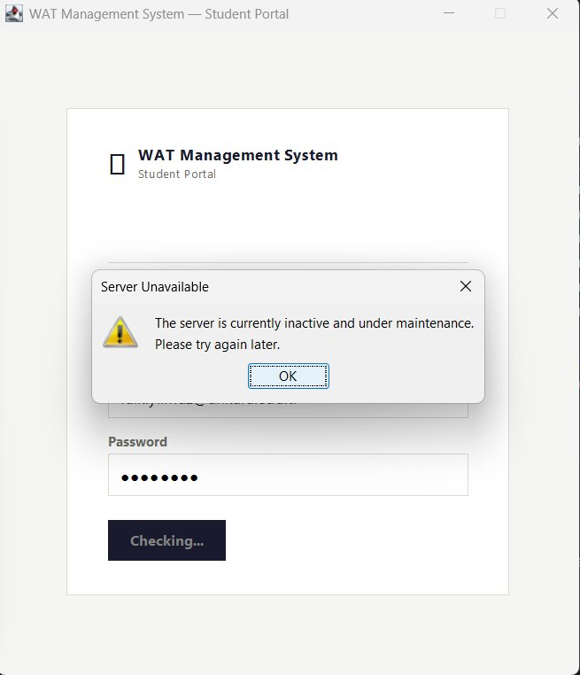
Figure 2. Sign-in screen when the database server is offline — the client probes the JDBC URL with isServerAvailable() and pops up a maintenance dialog.
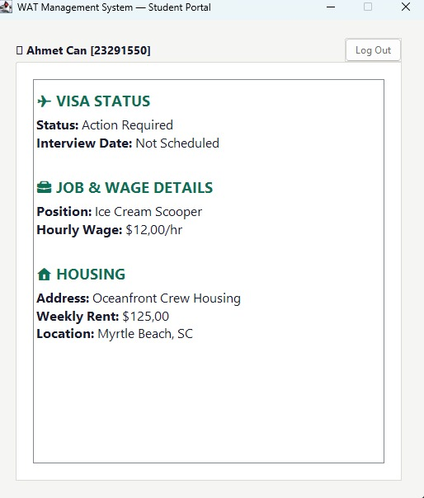
Figure 3. Personal dashboard rendered after a successful login — visa status, accepted job, hourly wage, assigned housing and U.S. location are all retrieved from the live database in a single LEFT JOIN query (see §5.4).
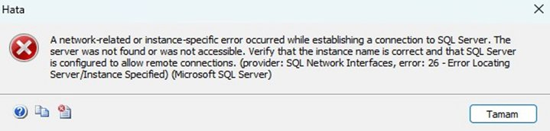
Figure 4. The corresponding SQL Server connection error reported by SQL Server Management Studio when the SQLEXPRESS instance is not running.
Together these three views verify that the system covers both the happy path and the failure path: when the back-end is reachable, the dashboard query in §5.4 returns a real row that is rendered on screen for the user; when the back-end is down, both the Java client and SSMS report a clean, recognisable error rather than crashing or hanging.

5. Representative SQL Queries
This section presents five representative queries that demonstrate the analytical reach of the schema. Each query is followed by a short narrative explanation and the result set obtained from the populated database.

5.1 Q1 — Students Whose Visa Application is Still Pending
This query lists every student whose consulate interview has been scheduled but whose visa is still under review. It joins STUDENT and VISA_PROCESS on the StudentID foreign key:
SELECT s.StudentID, s.FirstName, s.LastName,
v.SevisID, v.InterviewDate
FROM STUDENT s
JOIN VISA_PROCESS v ON s.StudentID = v.StudentID
WHERE v.Status = 'Pending'
ORDER BY v.InterviewDate;

StudentID | FirstName | LastName | SevisID | InterviewDate
23291002 | Burak | Demir | N002000002 | 2026-04-10
23291005 | Emre | Yildiz | N002000005 | 2026-04-12
22290579 | Furkan | Duran | N001234568 | 2026-04-18
23291001 | Ayse | Kaya | N002000008 | 2026-04-25
23291004 | Deniz | Celik | N002000004 | 2026-04-28
23291007 | Gokhan | Aydin | N002000007 | 2026-05-02
23291009 | Irem | Arslan | N002000009 | 2026-05-05
23291012 | Mustafa | Cetinkaya | N002000012 | 2026-05-10
23291015 | Pelin | Bulut | N002000015 | 2026-05-12
23291018 | Tolga | Yavuz | N002000018 | 2026-05-15

5.2 Q2 — Total Payments Collected per Agency
This query joins three tables to produce a financial summary of how much each agency has collected from its students. It uses an aggregate (SUM) and a GROUP BY clause:
SELECT a.AgencyName,
COUNT(DISTINCT s.StudentID) AS NumStudents,
SUM(p.Amount) AS TotalCollected
FROM AGENCY a
JOIN STUDENT s ON s.AgencyID = a.AgencyID
JOIN PAYMENT p ON p.StudentID = s.StudentID
GROUP BY a.AgencyName
ORDER BY TotalCollected DESC;

AgencyName | NumStudents | TotalCollected (USD)
Armada Grandee | 3 | 1,750.00
Success | 3 | 2,000.00
YERO | 2 | 1,250.00
StudyZONE | 3 | 1,750.00
CampusEDU | 3 | 2,000.00
United Towers | 3 | 1,750.00
Global Vizyon | 3 | 2,000.00
Westline International | 3 | 1,750.00
Öztek International | 3 | 1,750.00
Advice Yurtdışı Eğitim | 2 | 1,000.00

5.3 Q3 — Highest-Paying Position Available in Each State
This query identifies the best paying job currently listed in every U.S. state, which is the kind of question a student naturally asks before applying. It uses MAX with GROUP BY and joins JOB_OFFER with LOCATION:
SELECT l.State,
MAX(j.HourlyWage) AS TopWage,
COUNT(j.JobID) AS NumJobs
FROM JOB_OFFER j
JOIN LOCATION l ON j.LocationID = l.LocationID
GROUP BY l.State
ORDER BY TopWage DESC;

State | TopWage (USD/hr) | NumJobs
TN | 18.50 | 2
MA | 18.00 | 4
FL | 17.00 | 8
OR | 17.00 | 3
WI | 17.00 | 5
MI | 16.00 | 2
MN | 16.00 | 2
NJ | 16.50 | 4
OH | 16.00 | 4
MD | 16.00 | 6
SC | 15.50 | 9
TX | 15.50 | 1

5.4 Q4 — Personal Process Dashboard for a Single Student
The dashboard query brings together five tables in a single SELECT and is the one issued by the Java client whenever a student opens their personal panel. It is shown here for student 23291550 (Ahmet Can), whose live dashboard view is reproduced in Figure 3 of the previous section:
SELECT v.Status AS VisaStatus,
v.InterviewDate,
j.PositionTitle,
j.HourlyWage,
h.Address AS HousingAddress,
h.CostPerWeek AS HousingCost,
l.City, l.State
FROM STUDENT s
LEFT JOIN VISA_PROCESS v ON s.StudentID = v.StudentID
LEFT JOIN APPLICATION a ON s.StudentID = a.StudentID
LEFT JOIN JOB_OFFER j ON a.JobID = j.JobID
LEFT JOIN LOCATION l ON j.LocationID = l.LocationID
LEFT JOIN HOUSING h ON l.LocationID = h.LocationID
WHERE s.StudentID = 23291550;

Field | Value
VisaStatus | Action Required
InterviewDate | Not Scheduled
PositionTitle | Ice Cream Scooper
HourlyWage | $12.00 / hr
HousingAddress | Oceanfront Crew Housing
HousingCost | $125.00 / week
Location | Myrtle Beach, SC
The rows returned by this query map directly to the fields rendered in the dashboard view shown earlier — proof that the Java client is reading the live database rather than displaying static content.

5.5 Q5 — Jobs With No Active Application
The final query returns every job offer that has not yet been accepted by any student. It demonstrates the use of a NOT EXISTS sub-query to express the absence of a matching record in the bridge table:
SELECT j.JobID, j.PositionTitle, j.HourlyWage,
e.CompanyName, l.City, l.State
FROM JOB_OFFER j
JOIN EMPLOYER e ON j.EmployerID = e.EmployerID
JOIN LOCATION l ON j.LocationID = l.LocationID
WHERE NOT EXISTS (
SELECT 1 FROM APPLICATION a
WHERE a.JobID = j.JobID
AND a.AppStatus = 'Accepted'
)
ORDER BY j.HourlyWage DESC;

The result set contains roughly 45 open positions; the first five rows are reproduced below to keep the report concise:
JobID | PositionTitle | HourlyWage | CompanyName | Location
151 | Line Cook | $18.00 | The Lobster Pot | Provincetown, MA
104 | Prep Cook | $17.00 | Stimulus Coffee + Bakery | Pacific City, OR
121 | Kitchen Prep | $17.00 | The Lobster Pot | Provincetown, MA
137 | Front Desk Agent | $17.00 | Marriott Resort | Destin, FL
148 | Server | $17.00 | Dave & Buster's | Nashville, TN

6. Conclusion
This project delivered a complete Work and Travel Student Management System covering the full pipeline from agency registration to job placement and housing assignment. The core deliverables include: a normalised nine-table relational schema implemented on Microsoft SQL Server; a populated data set of 25 students, 32 employers and 60 job offers that exercises every relationship in the model; a three-layer Java desktop client that authenticates students, lets them browse and apply for jobs, and renders their progress on a personalised dashboard; and a representative collection of SQL queries that demonstrate the analytical power of the schema.
Designing the schema reinforced the value of normalization. Splitting the city/state pair into its own LOCATION table, for example, made the cascading queries between job offers and housing far more natural to write. Introducing APPLICATION as a bridge entity instead of embedding job references inside STUDENT made it possible to track multiple, dated submissions per student without violating first normal form. The discipline of declaring every foreign key in the DDL paid off the moment the Java client began issuing INSERT statements: invalid AgencyID or LocationID values were rejected by the engine before they could pollute the data.
The clearest lesson from the implementation phase concerns the boundary between database constraints and application logic. The schema enforces structural integrity — keys, types, references — but business rules such as 'a job offer may have at most one Accepted application' are policed inside applyToJob in the Java layer using an explicit transaction and a SELECT … FOR UPDATE-style probe. In future iterations these checks could be promoted into the database itself as triggers or as a CHECK constraint backed by a computed column, which would protect the schema from being modified through tools other than the Swing client.
Possible extensions include a web front-end implemented with Spring Boot, role-based access control to expose distinct administrator and student views, automatic notification when a visa status changes, and the addition of seasonal pricing for housing units to relax the assumption of constant weekly rent. Within the scope of COM2058, however, the present system already demonstrates a working, end-to-end relational application that satisfies all requirements set out in §2.

